**Problem Statement:**

You work for XYZ Corporation. Your corporation is working on an application and

they require secured web servers on Linux to launch the application.

**Tasks To Be Performed:**

1. Create an instance in the US-East-1 (N. Virginia) region with Linux OS and

manage the requirement of web servers of your company using AMI.

Created instance of Linux OS

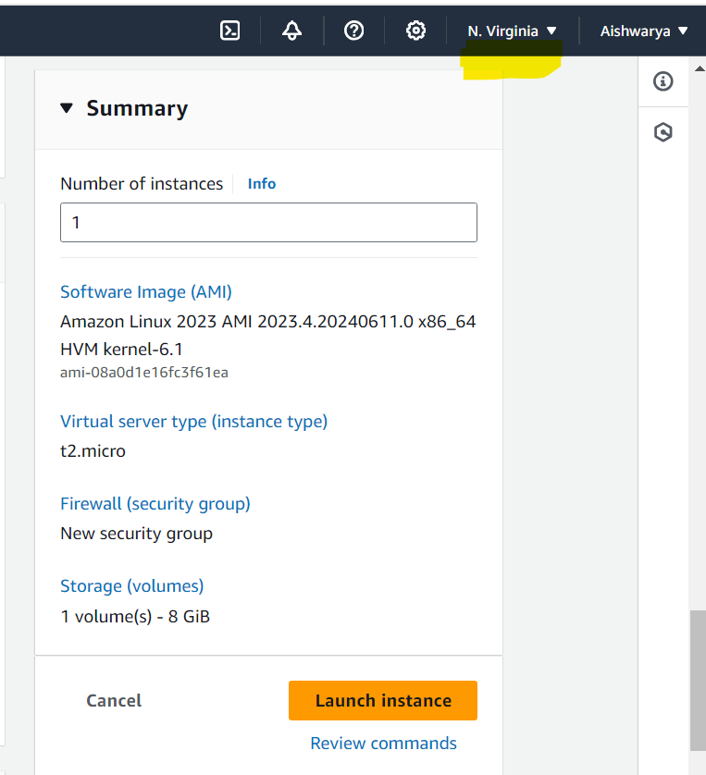

Connect to instance and install apache2.

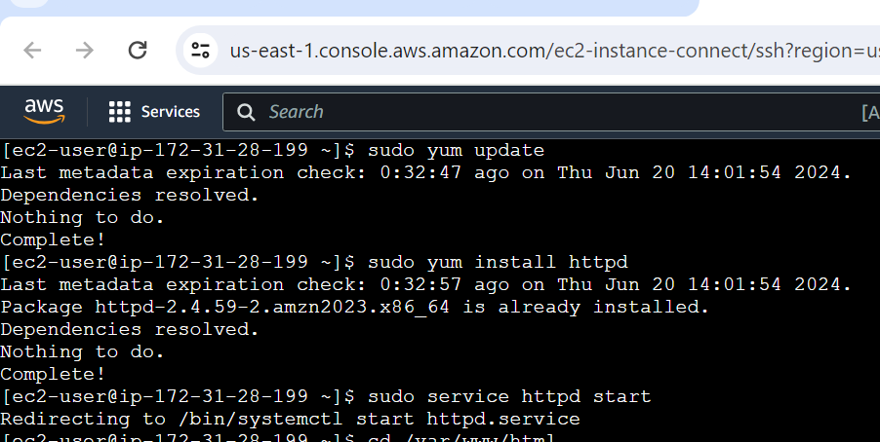



Create AMI using the Instance

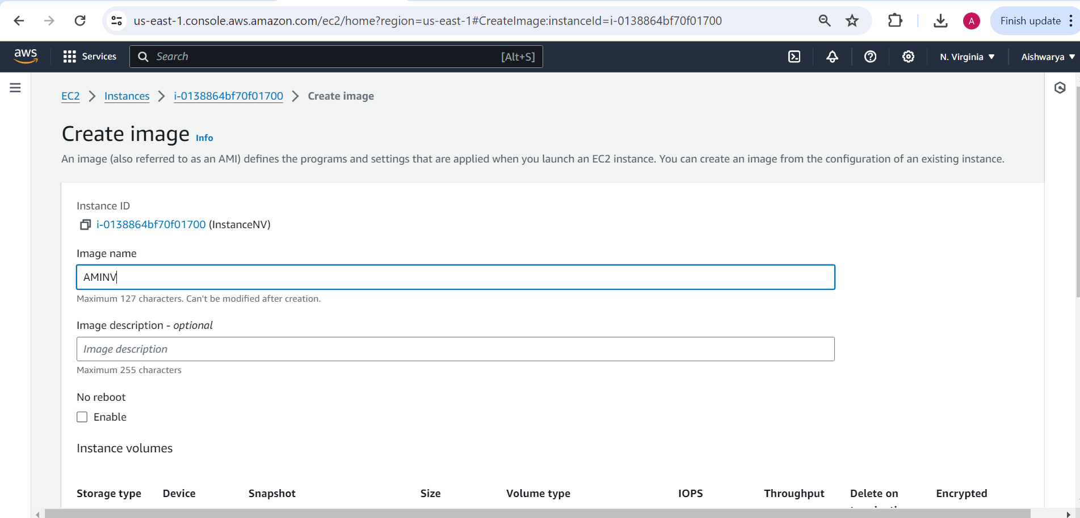

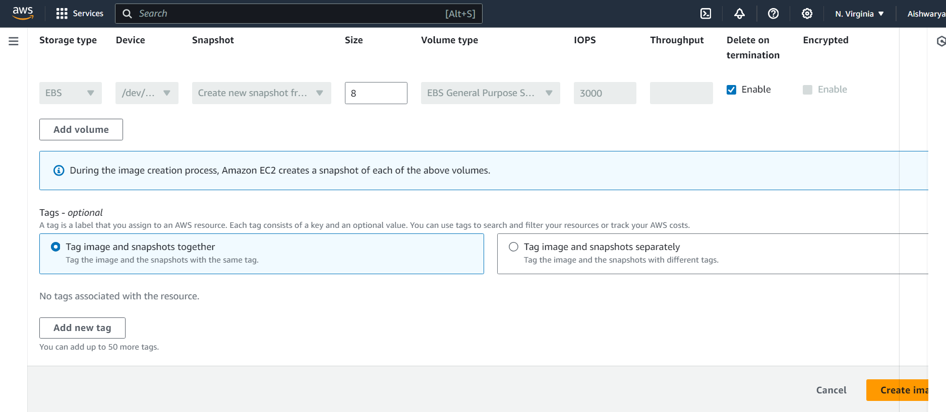

2. Replicate the instance in the US-West-2 (Oregon) region.

Copy AMI into Oregon

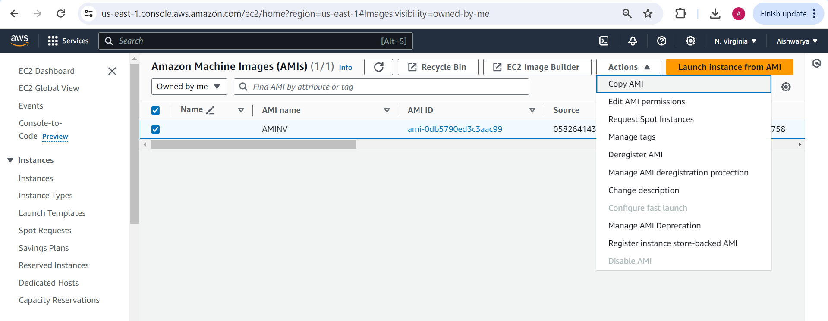

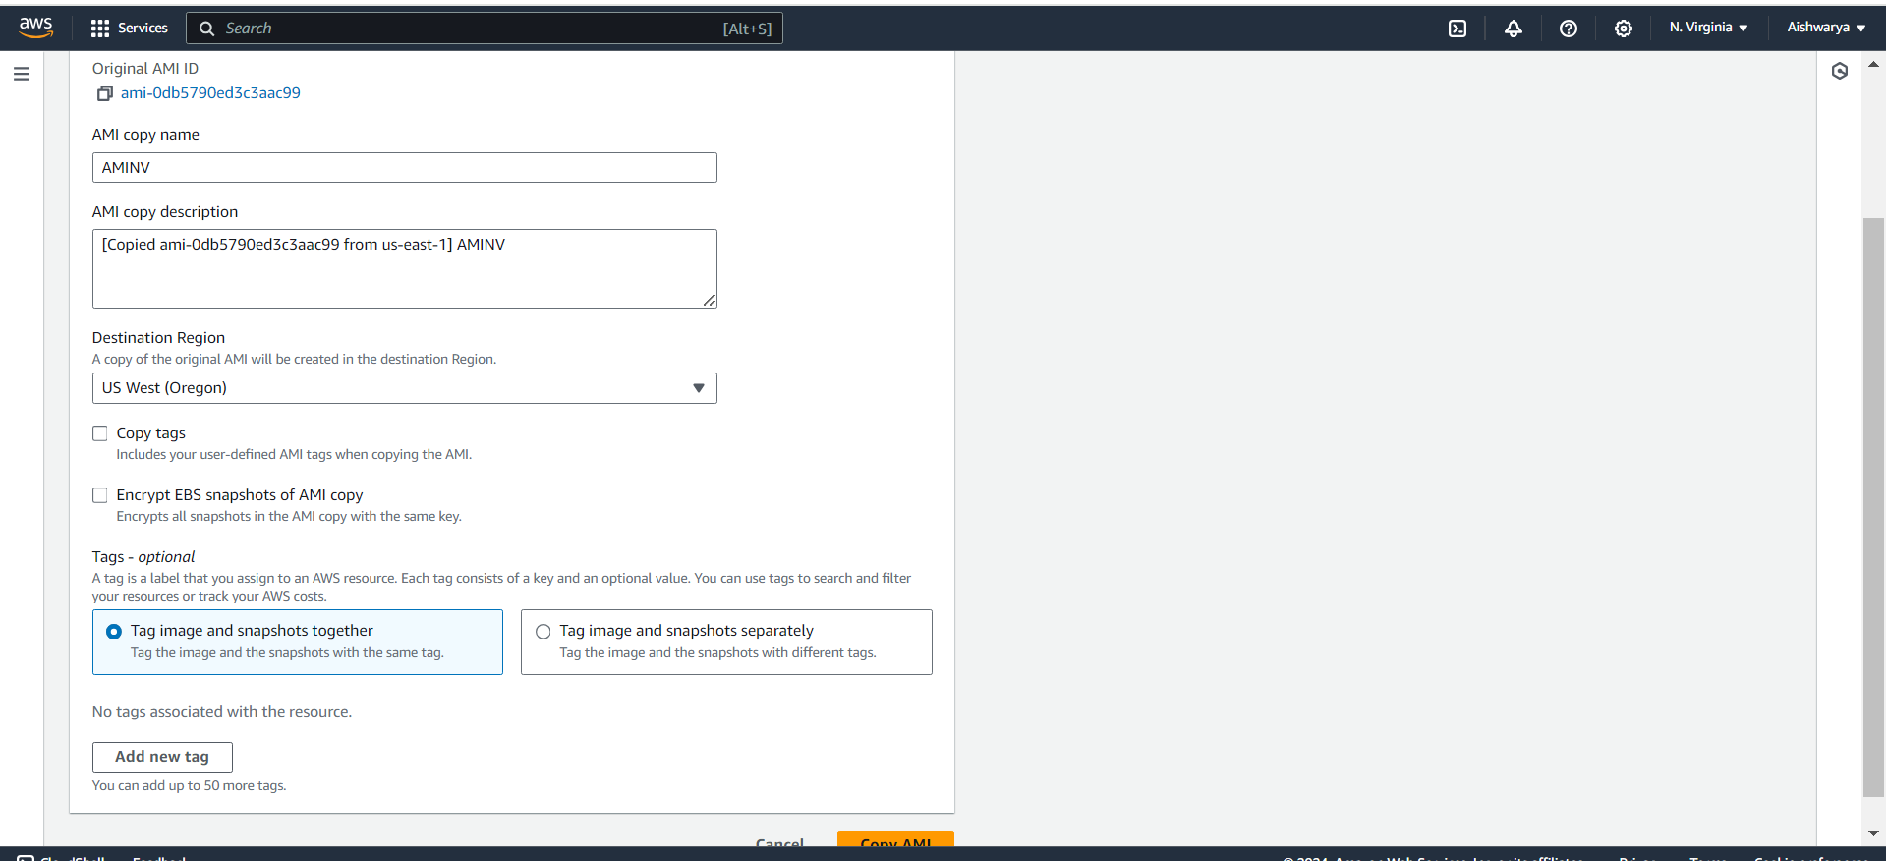

AMI gets copied in Oregon region

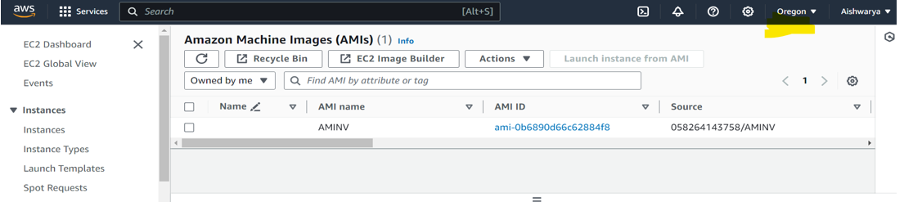

Replicate Instance (create instance) from copied AMI

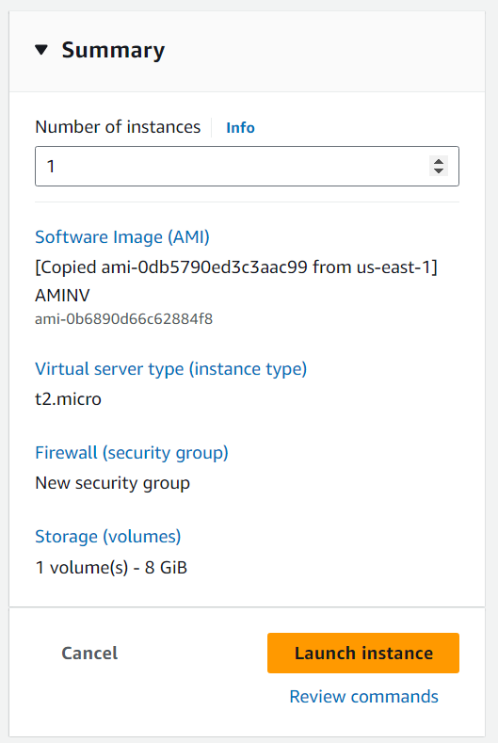

3. Build two EBS volumes and attach them to the instance in the US-East-1

(N. Virginia) region.

Create volume

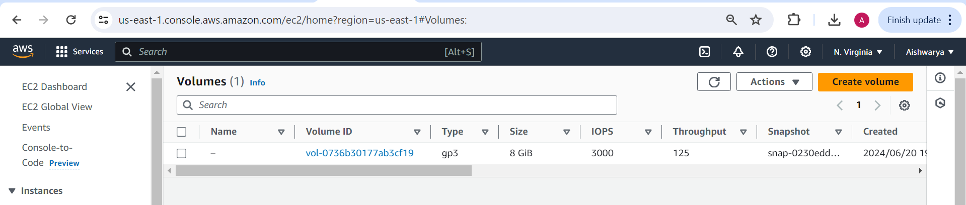

Created 1st volume of 5 GiB with AZ us-east-1c as instance present in this AZ

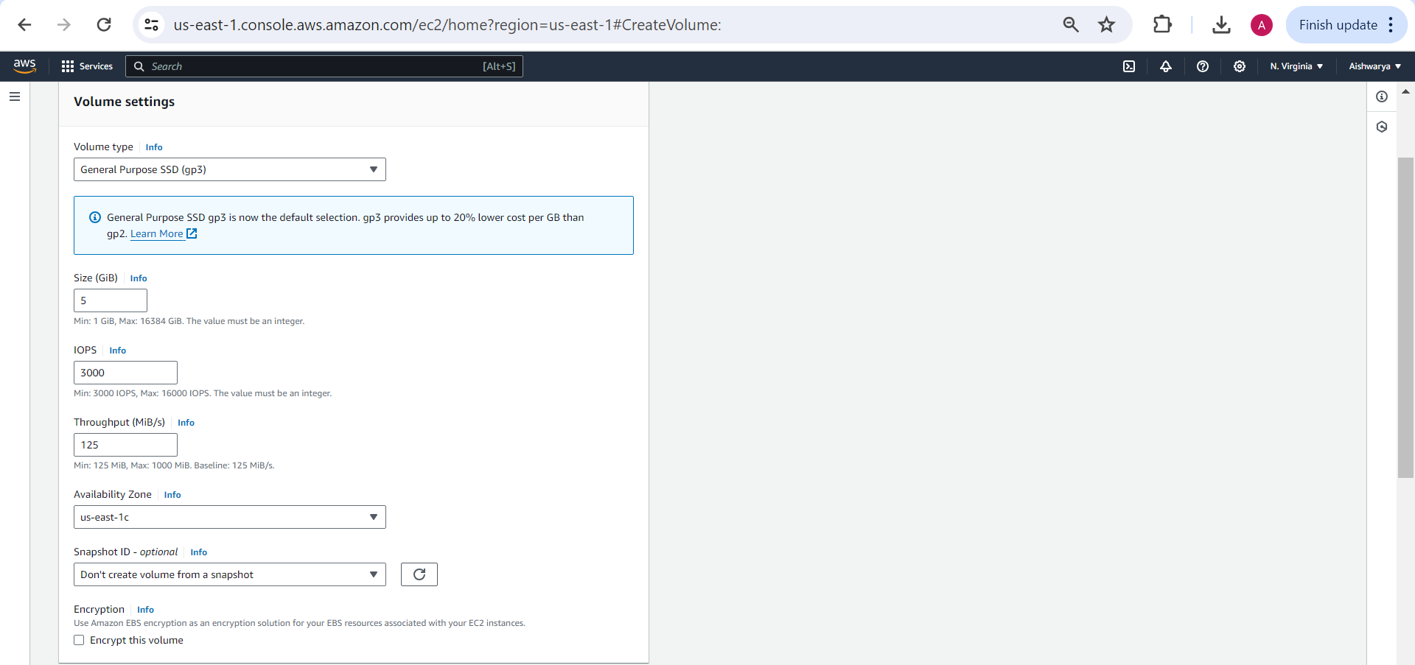

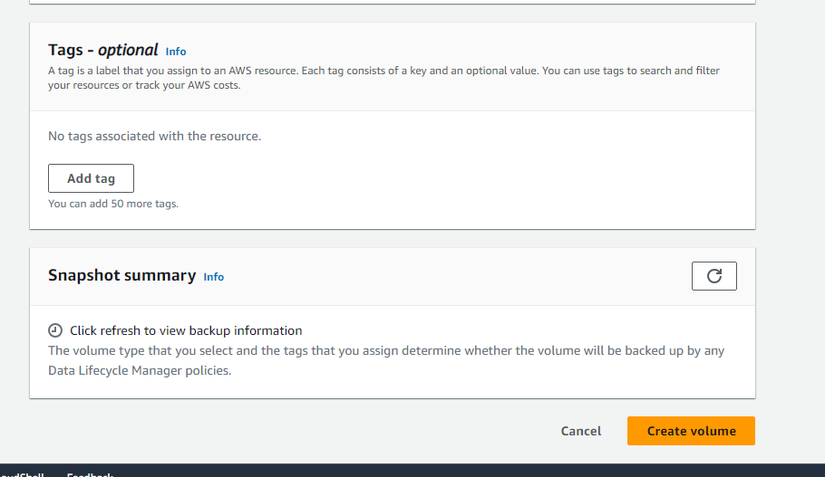

Create 2nd volume of 10 GiB with AZ us-east-1c as instance present in this AZ

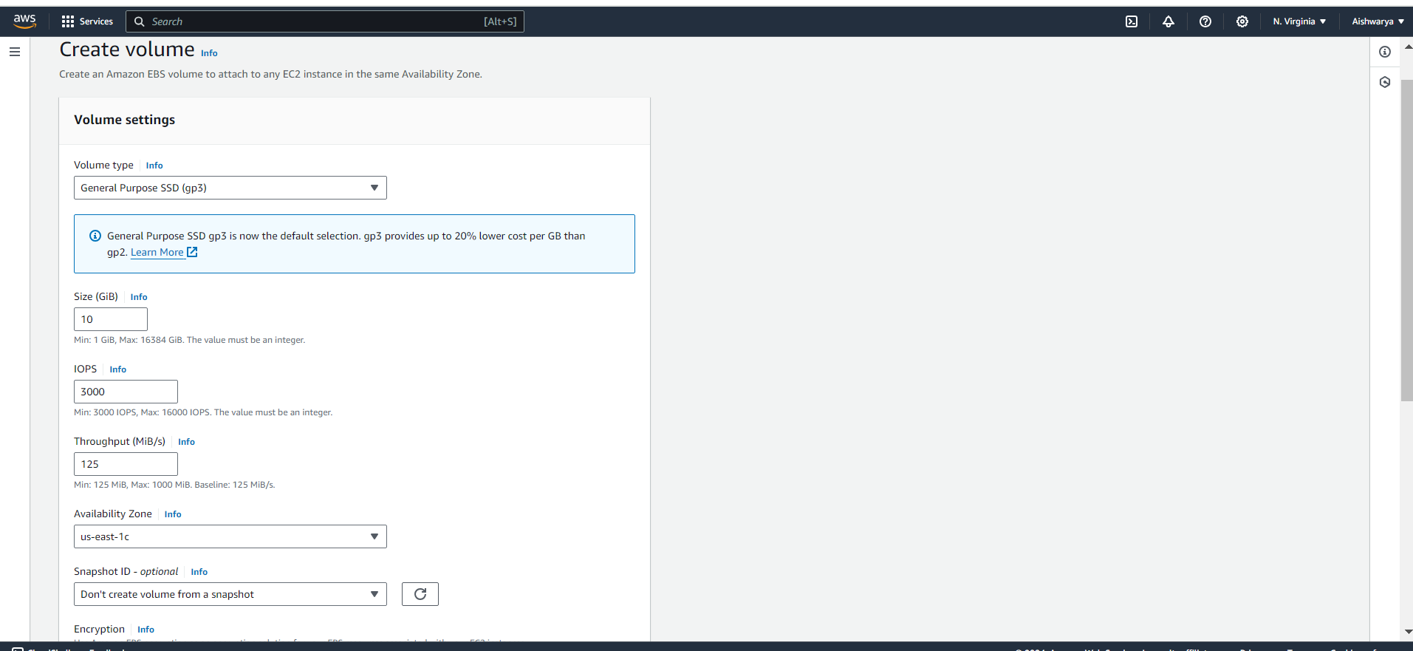

Two volumes get created.

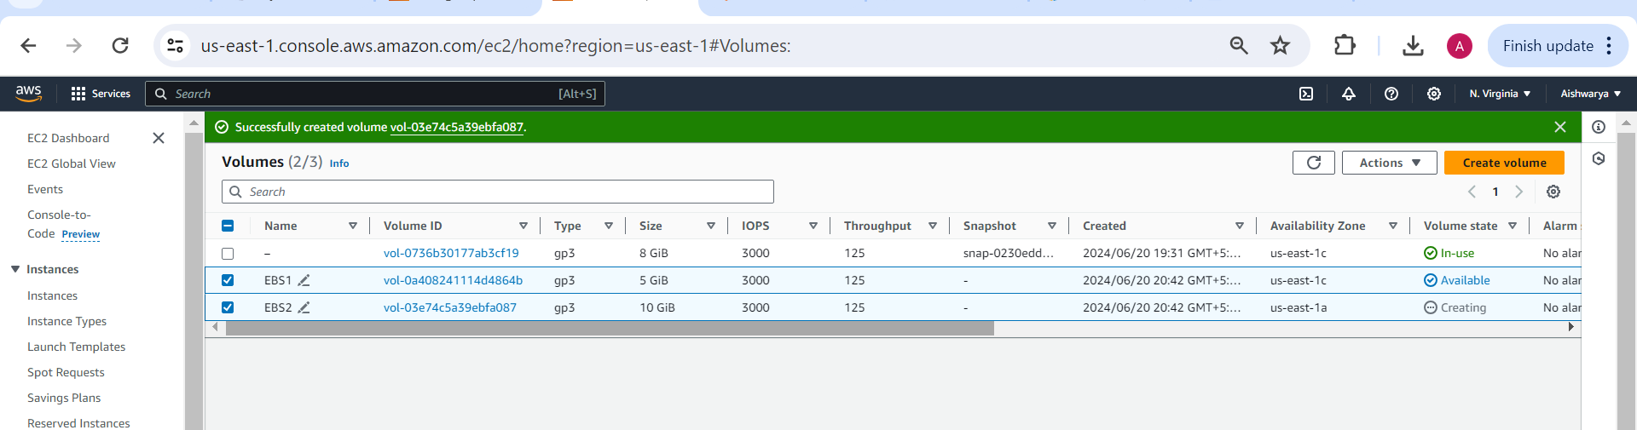

Attaching 1st EBS volume to instance in the US-East-1 (N. Virginia) region.

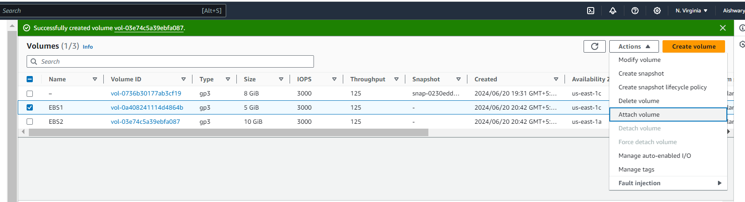

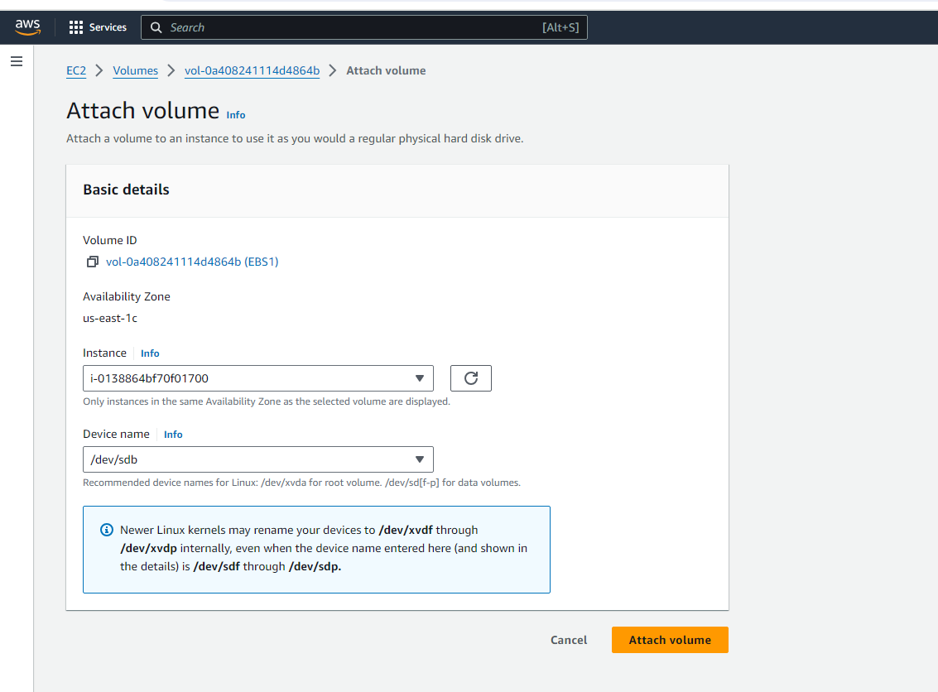

Attaching 2nd EBS volume to instance in the US-East-1 (N. Virginia) region.

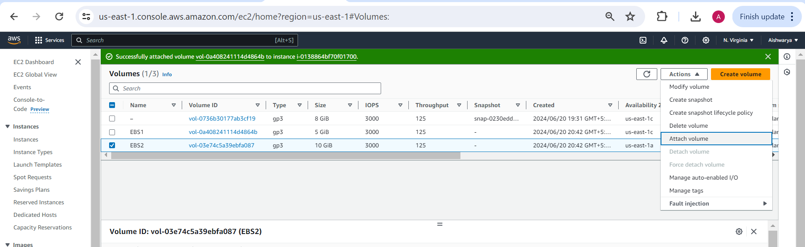

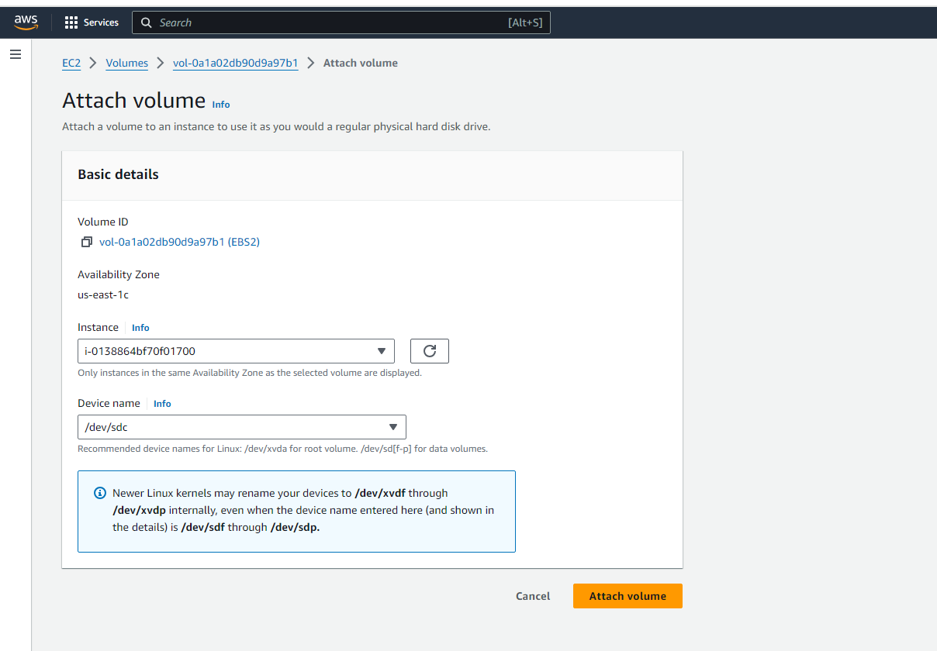

4. Delete one volume after detaching it and extend the size of the other

volume.

Detaching the 1st volume

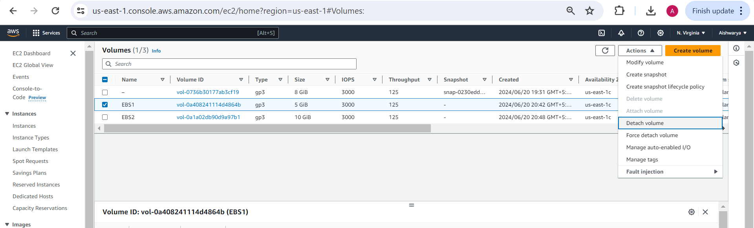

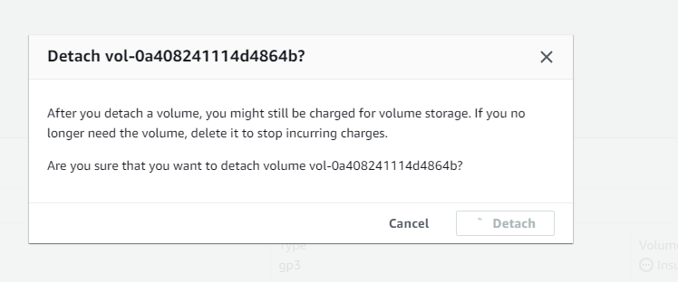

Now delete the volume

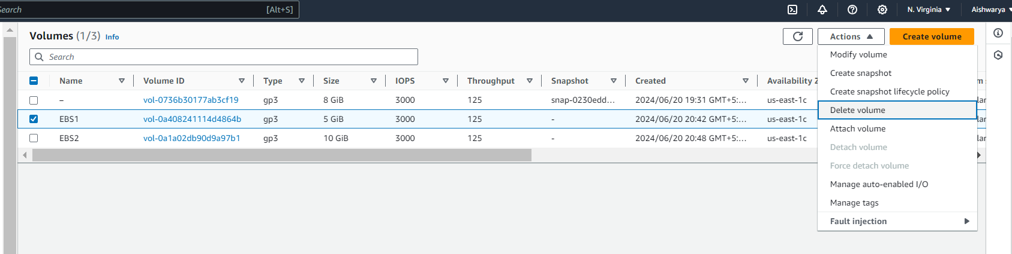

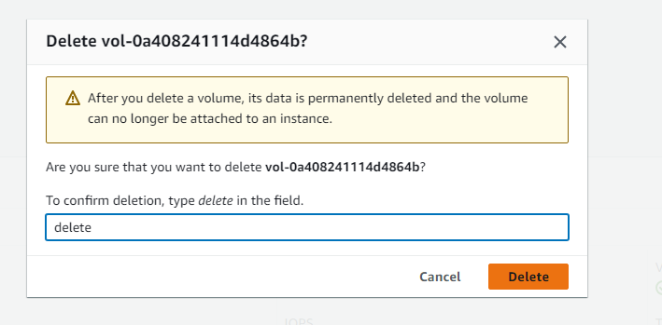

Modify the size of EBS volume from 10GiB to 12 GiB

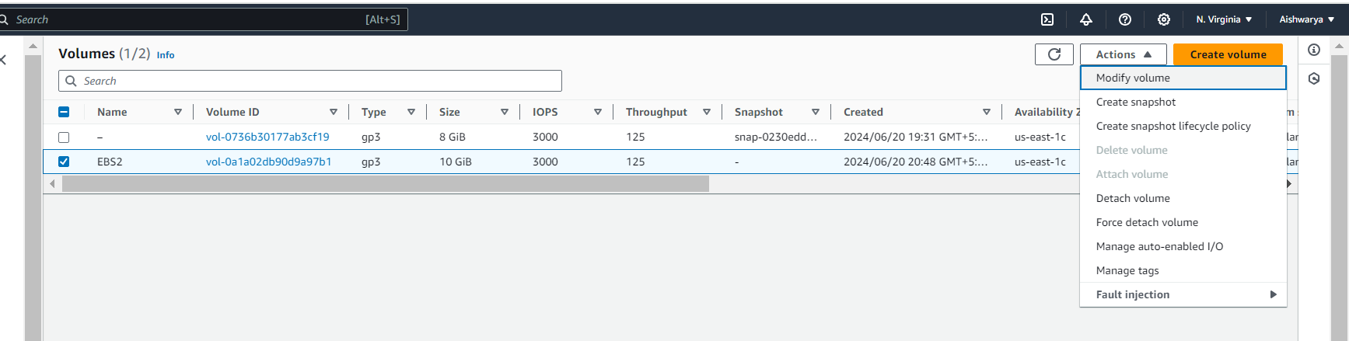

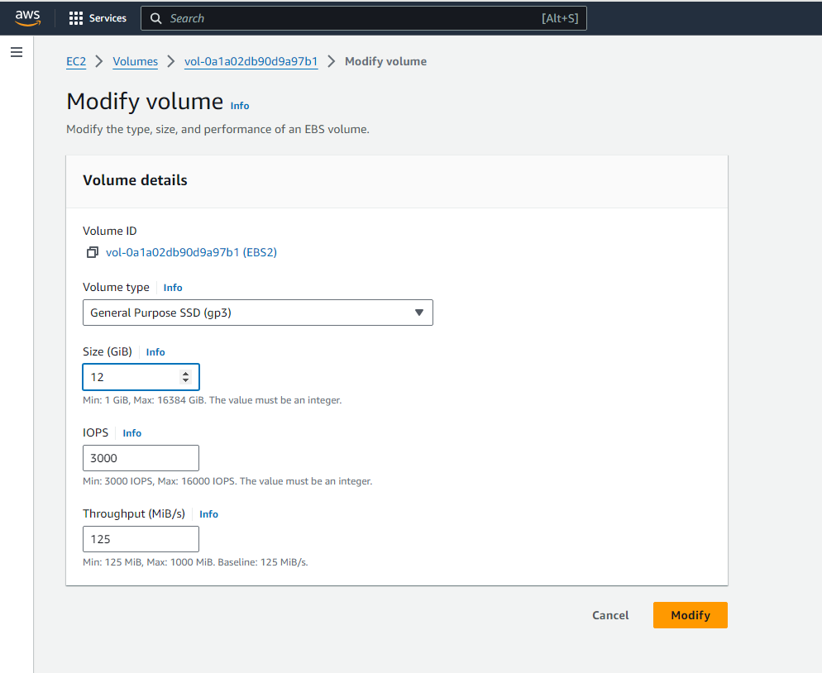

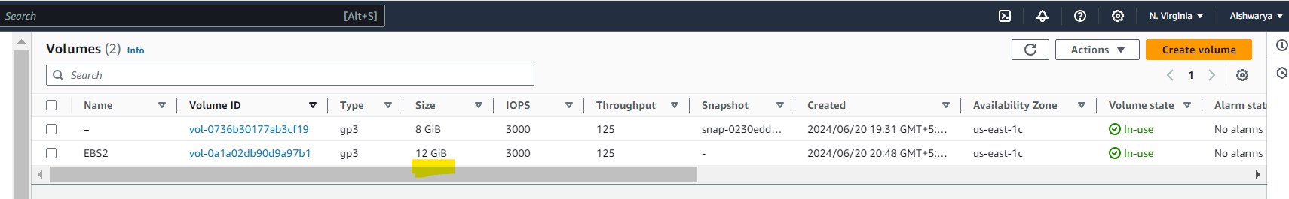

5. Take backup of this EBS volume

Create the snapshot of EBS volume.

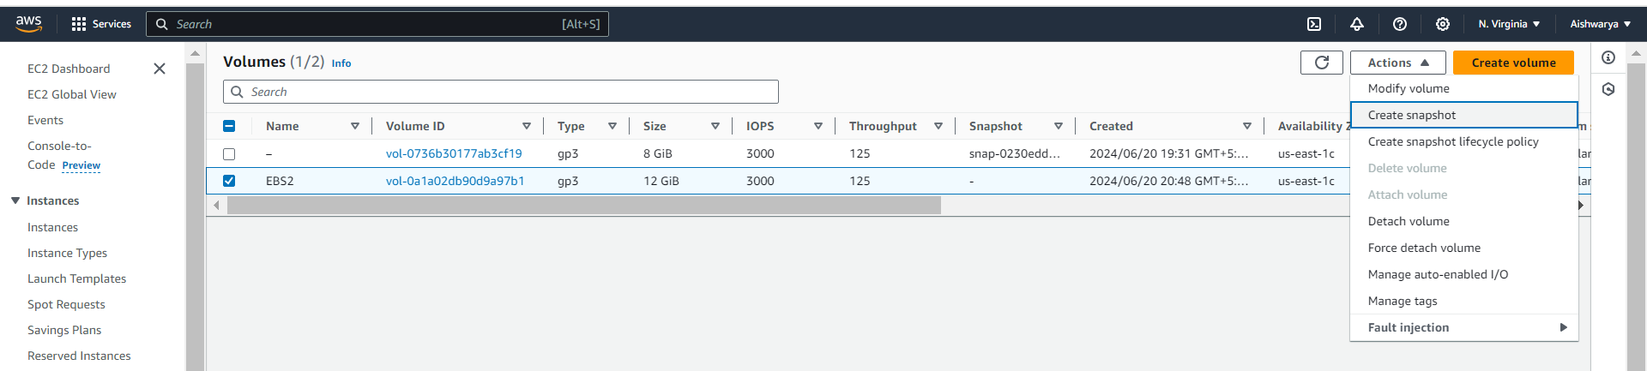

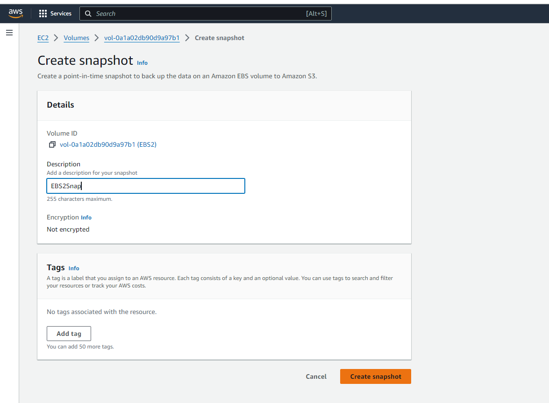

Snapshot got created

